**Chess GUI Manual Test Plan**

Action: Start game

Expected Response: View of Chess Board with black and white pieces in their traditional spots with menu bar that shows information and has undo/restart/forfeit commands.

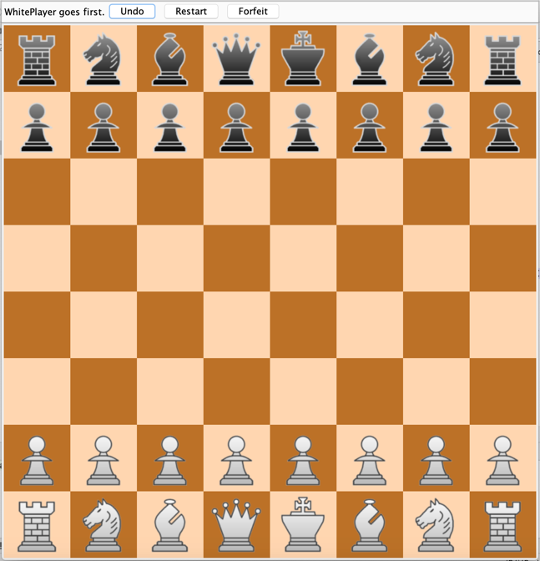

Action: Close game window

Expected Response: The game process stops running.



Action: Chess piece icon is clicked on and dragged

Expected Response: The icon follows the mouse around the window.



Action: Chess piece icon is clicked on and dragged to a tile with no piece.

Expected Response: The icon follows the mouse and gets places on the empty tile.

Action: Chess piece icon is clicked on and dragged to a tile with a piece.

Expected Response: The icon follows the mouse and when let go, goes back its source tile.

Action: An invalid move with the chess piece is made.

Expected Response: The icon will go back to it’s source tile and a message saying “Invalid move. Try again” in the menu bar.



Action: Capture a piece with a valid move.

Expected Response: The captured piece’s icon will disappear, and get replaced. A message saying “Piece captured successfully” shows up on the menu bar.



Action: Capture the opponent’s King piece.

Expected Response: The captured piece’s icon will disappear, and get replaced. A message box saying “Checkmate! [Current Player’s name] wins!” shows up.



Action: Restart button is pressed.

Expected Response: A message will popup asking if both players want to restart the game. If OK, the game is closed. If cancelled, the game keeps going.



Action: Press Undo button

Expected Response: Undo’s last move, and undo’s the turn as well.



Action: Start of game

Expected Response: A popup asks player if they want to use custom pieces. If they say OK, the game starts with the custom pieces. If they say cancel, the game starts with only the normal pieces.

